Notes for Sheriff on last mockup pages June 18, 2026

Please standardize these points for all packages:
- Your dedicated representative will meet you at Cairo airport (CAI) with a name sign.
- On the top (above overview…………….) add Accommodation: 5 stars.
- Add Beverages to exclusions in packages that include cruises
- Tour at a glance , Guide (add English, other languages on request).
- Tour at a glance, change Transport to Transportation (better for americans).
- Tour at a glance, change Visa to Entry Visa.
- Highlights , the red numbering doesn’t look very nice; maybe we try a different color?Day by dad
- : after the description of each day we should add: Overnight in ….. ; it adds more clarity to first time traveler.
- Day by day: I think we should mark the sites described in the itinerary in blue.

8 days/ 7 nights
- Day by day. Day 5: add (add-on: Abu Simble if time allows). Very important because some people might decide not to book with us in case we don’t offer that option.

9days /8 nights (most popular package).
- Introduction wasn’t changed (I sent you a different one).
- Day 4 we should write East Bank Tour next to Luxor, next line should be Karnak and Luxor Temples – Nile Cruise Boarding (Compare to Day 5).

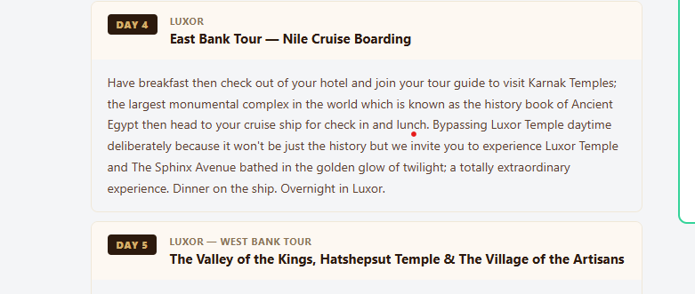
7 days / 6 nights
- Introduction wasn’t changed (I sent you a different one).
- Optional add-on : Remove pick up from Hurghada , add Sound &light show at the pyramids.

